CEG2136 Computer Architecture I

Lab2
Design and Simulation of Sequential Logic Circuits
-Synchronous counter-

Professor: Voicu Groza, P.Eng.
Dr. Fadi Malek
TA: Harman
Nayma
Sonal

University of Ottawa
Faculty of Engineering

2019 FALL
September 24​^{th​}2019

______________________________________________________________________________
Group Number: 8
Student Name: Jiajie Xu
Student Number:

Student Name:
Student Number:
Theoretical Part

1. Presentation of the lab problem in a nutshell:

Two synchronous counters, a 3-bit and a 4-bit, implemented with JK-Flip Flops were presented as the lab problem and each output of them had been logically analyzed using Karnaugh Maps in prelab. It then was constructed as block diagram using Quartus II designing software and functioned onto the push button, LEDs and the first switcher on DE2-115 Board. Waveforms were generated and analyzed as if logically corrected. Designed circuit then tested on the board to see if the outputs were correct while applying the clock-input. Part I of the lab is shown as above. Following into Part II, designed circuit was then re-compiled and functioned onto Expansion Headers and SMA Ext Clock-out on DE2-115 Board to connect to Oscilloscope using probe kit. Patterns of circuits’ clock-outs and outputs shown on Oscilloscope DIsplay were compared with their waveforms.

Purpose of the lab:

The lab is mandatoried since it would give students a view of how to trans the functional requirements to actual logic circuits and provided a chance for practicing on using digital equipment.

.

- Discussion of the problem (specifications/requirements, diagrams, flowcharts)​: During the lab, compilation part for the part a.

The compilation shows 3 errors occurred and failed.
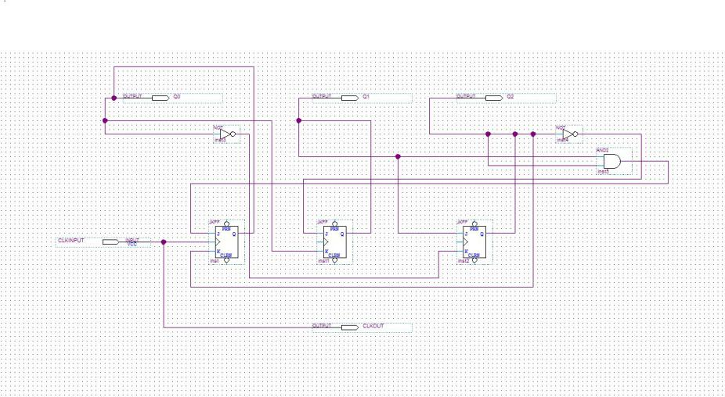

The block diagram is being reviewed again and found out that the clock for the J1K1 and J2K2 were not connected with J0K0.
The clock had been connect again, project was recompilated again and shows 0 error occurred, therefore,succeed.

3. Discussion of the algorithmic solution:

The block diagram had been reviewed again and found out that the clock for the J1K1 and J2K2 were not connected with J0K0.
The clock had been connect again, project was recompiled again and shows 0 error occurred, therefore, succeed.
DESIGN PART

- Prelab for PART I

J0=Q1Q2 K0=Q2

J1=Q2K1=Q0

J2=Q2’ K2=Q0’

- Prelab for PARTII J0=Q1’Q2’+Q3 K0=1
J1=Q0Q3’K1=Q0+Q3

J2=Q0Q1Q3’K2=Q0Q1+Q3

J3=Q0Q1Q2K3=Q0+Q1+Q2

1.Presentation of the design for PART I 3 bit synchronous modulo 6 counter
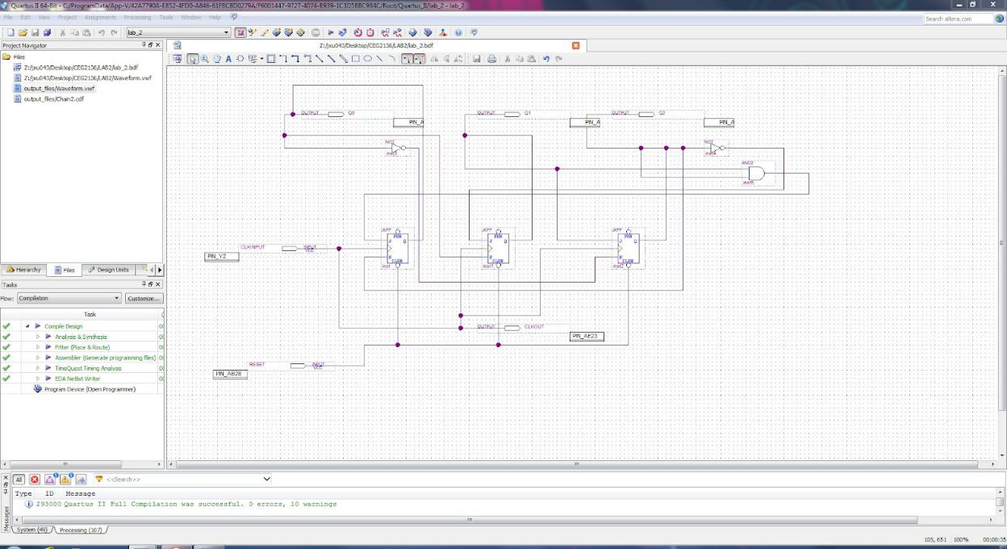

Figure 1: Block diagram with pin assignments complete for PART I
1.Presentation of the design for PART II 4 bit synchronous modulo BCD counter
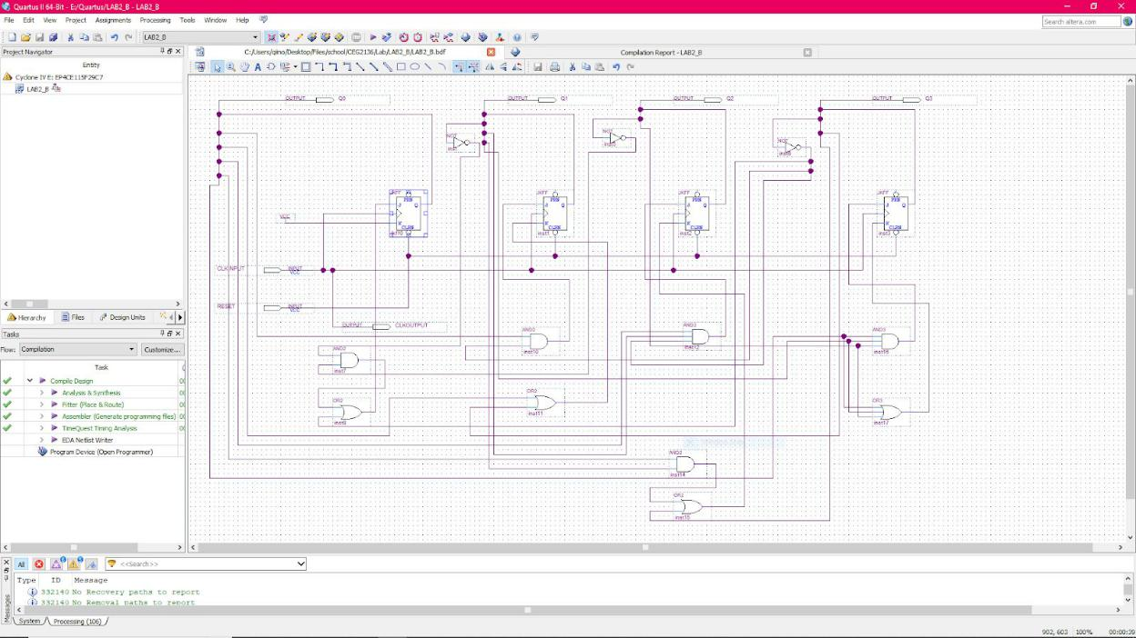

Figure 2: block diagram for the PART II

2. Discussion of used components:

Two major logical algorithms OR and AND were used to solve the problem. Logic or-gates with two and three inputs were used to represent the OR logic as block components.​The Logic OR Gate is a type of digital logic circuit whose output goes high to a logic level 1 only when one or more of its inputs are high. logic and-gates with two and three inputs were used likewise for logic AND expression. ​The Logic AND Gate is a type of digital logic circuit whose output goes high to a logic level 1 only​​when all of its inputs are high. Jk-Flip-Flops who save and present current and next states,played a significant role in counters.The JK Flip-flop is similar to the SR Flip-flop but there is no change in state when the J and K inputs are both low. logics above were used later in implementing block diagrams according to the outputs derived by Karnaugh Maps in prelab.

3. Discussion of actual solution:

Lab instruction had been read firstly before the lab section. The output of each JK-Flip-Flop in the counters were derived out by using Karnaugh Map. Counters of two tasks were then implemented in block diagrams. Each part of the circuit was named and connected. It was then compiled successfully with zero errors. Waveforms were simulated and showed the correct outputs comparing to Karnaugh Maps. Clock input and outputs were applied onto the first push button and three LED lights above it. The counter was then tested on the Altera DE2-115 Board. The clock output and outputs of the counter were then reconnected to SMA EXT CLOCK IN and Expansion headers after having the first test approved. Range of the waveform was adjusted to a proper position and work was shown to TA.

- Discussion of tool (Optional): Equipment and supplies:
  - Quartus II(web edition)

  - Altera DE2-115 Board with USB Slater

  - Probe

  - Coaxial cable

  - Ribbon cable

  - Wires

  - Oscilloscope

- Discussion of challenging problems (Bonus):

During the lab, when time diagram of part B compiled, showed errors and could not get the correct waveform. Block diagram had been rechecked, no error found. The time diagram had been rechecked and found out that reset needed to be set to 1. After setting reset to 1, time diagram had been recompiled again and the result showed succeed.

Simulation and Verification Part

1. Shown simulation/synthesis results for PARTI
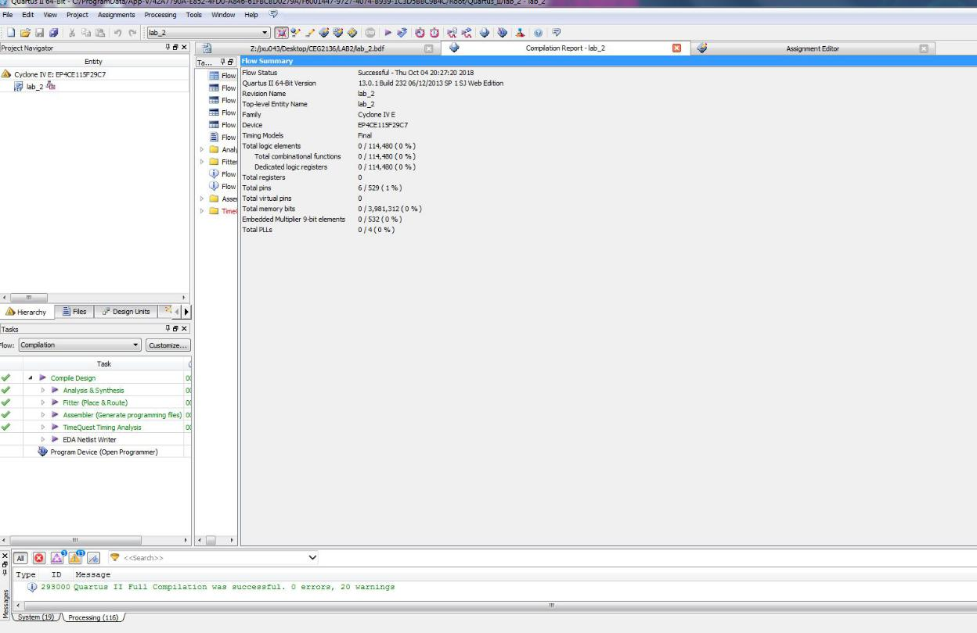

Figure 3: Screenshots of the compilation results 1
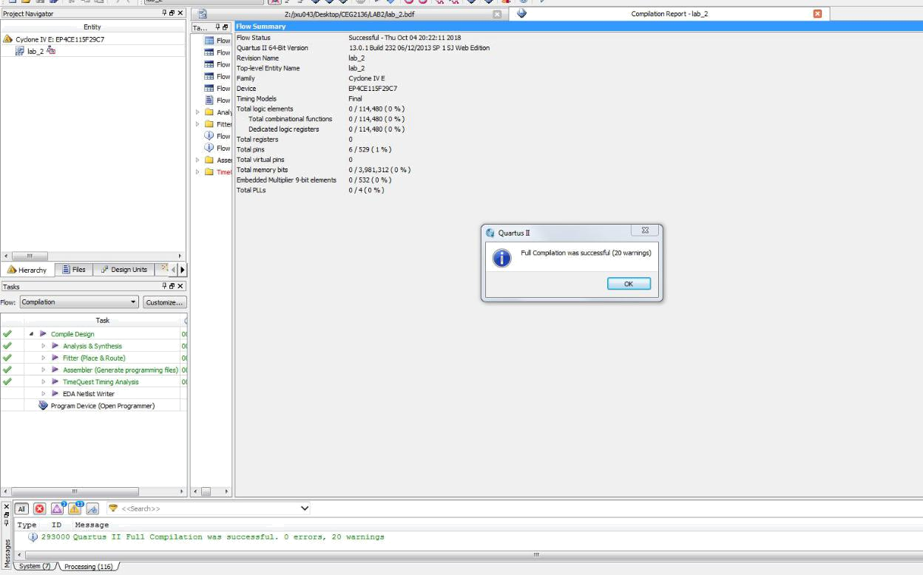

Figure 4: Screenshots of the compilation results 2
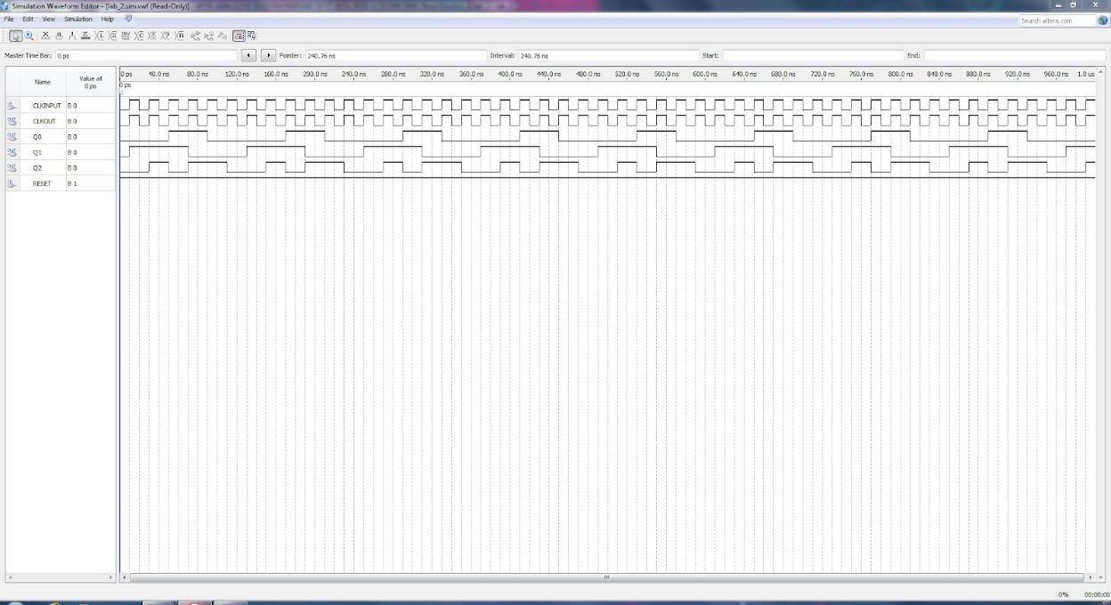

Figure 5: Screenshots of the waveform for the PART I
1. Shown simulation/synthesis results for PARTII
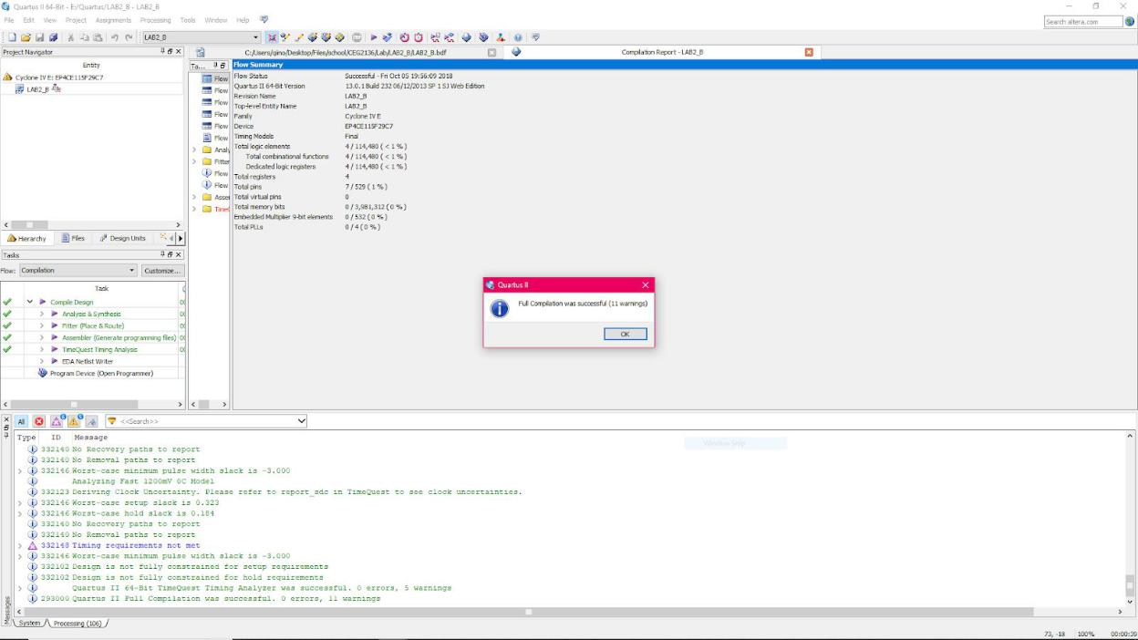

Figure 6: Screenshots of the compilation results 1
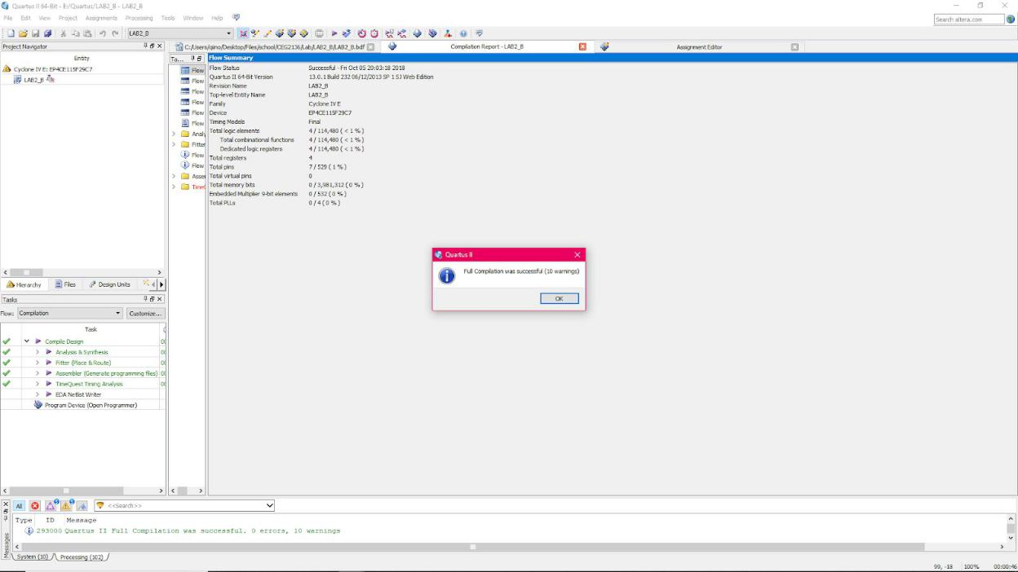

Figure 7: Screenshots of the compilation results 2
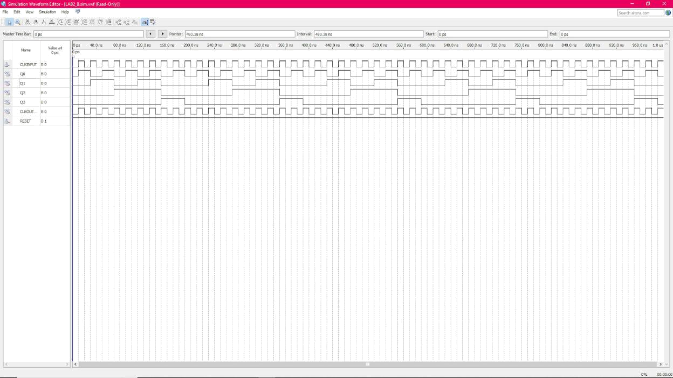

Figure 8: Screenshot of the waveform for the PART II
2. Experimental verification of operation of your circuits:
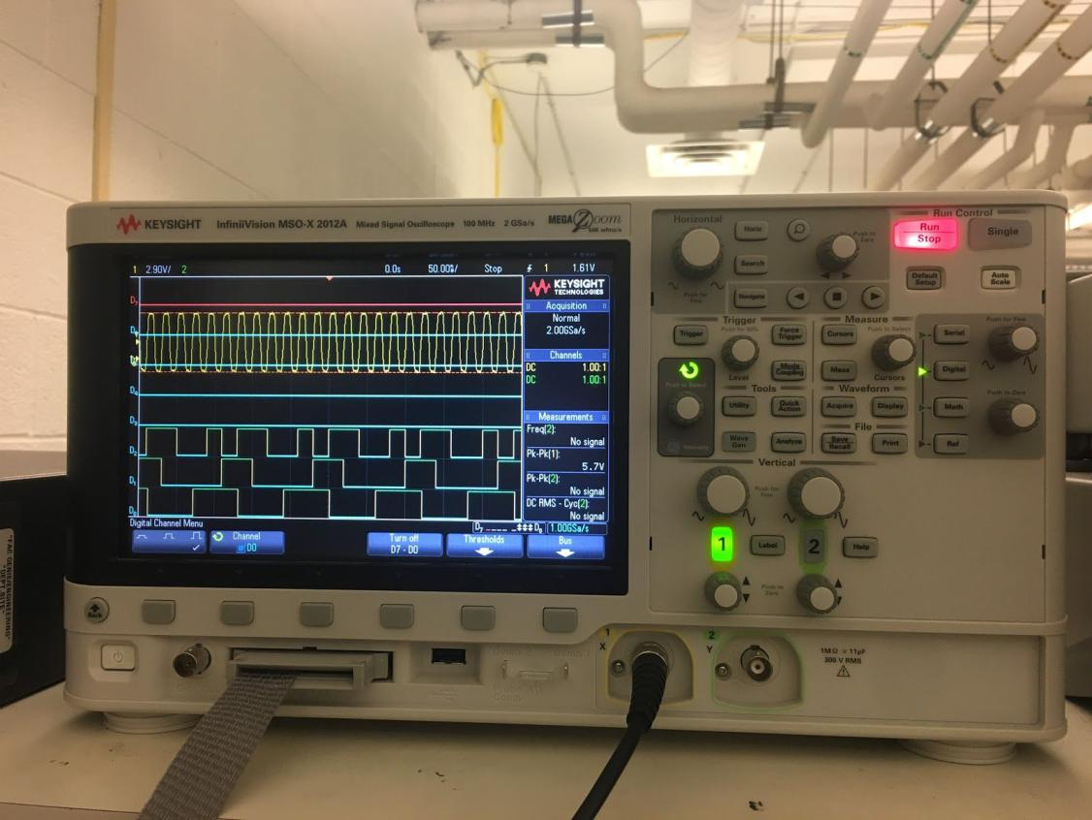

Figure 9 : Screenshot of successful test

Comment:

After it shows successful, checked with the prelab results. All of the inputs and output matches. In all, theoretical data matches experimental data and laws had been verified. Everything worked as expected.

Discussion and Conclusions

Circuit on the task was implemented on Quartus II software and tested on Altera DE2-115 board. The results of outputs were the same as the ones on Karnaugh Maps derived in prelab. Patterns of circuits’ clock-outs and outputs shown on Oscilloscope DIsplay were correct comparing with their waveforms. Therefore, the lab was successfully operated. Giving a briefly review of the Quartus II software and practising the knowledge learnt in class were the main points of this lab. During the lab, there are a few problems occurred while compiling the project on Quartus II and they were managed to be solved by asking for help from teaching assistance and following the instructions carefully.

